Research:
Graphic organizers have been applied across a range of curriculum subject areas. Although reading is by far the most well studied application, science, social studies, language arts, and math are additional content areas that are represented in the research base on graphic organizers. Operations such as mapping cause and effect, note taking, comparing and contrasting concepts, organizing problems and solutions, and relating information to main ideas or themes can be beneficial to many subject areas. The observed benefits in these subject areas go beyond those known to occur in reading comprehension (Bulgren, Schumaker, & Deshler, 1988; Darch, Carnine, & Kammenui, 1986; Herl, O'Neil, Chung, & Schacter, 1999; Willerman & Mac Harg, 1991).

Thinking Maps are graphic organizers that help students comprehend relationships between pieces of information. Students can more efficiently define, brainstorm, describe, compare and contrast, classify, sequence, and identify parts of a whole, cause and effect, and analogies.

Thinking Maps help students to structure writing projects, to help in problem solving, decision making, studying, planning, and researching.

Thinking Maps are best used to scaffold lessons so students can perform grade-level, standards-based work proficiently. They should be used as a means to an end or a tool to help students organize information that they will need to use for a later performance assessment.

Bubble Map – Use to describe qualities using adjectives  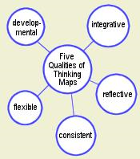 | Circle Map – Use to define or brainstorm ideas (Sources of Prior Knowledge are listed outside the circle)  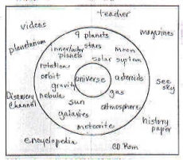
Tree Map – Use to categorize or classify items or ideas  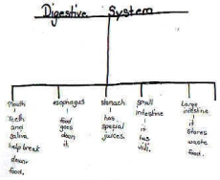 | Double Bubble Map – Use to compare and contrast  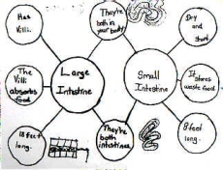

Flow Map – Use to sequence and order a process  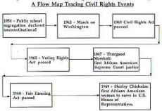 | Multi-Flow Map – Use to identify causes and effects  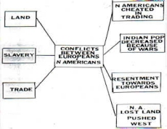
Brace Map – Use to analyze the structure of an item  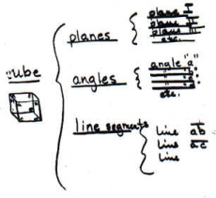 | Bridge Map – Use to identify similarities between relationships  